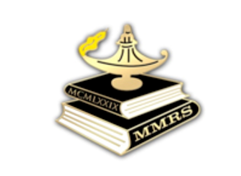 | Maryland Masonic Research Society (MMRS)  Membership Application

The purpose of MMRS is to promote any activity which may further knowledge or understanding of the history, ritual, philosophy, symbolism, or other aspects of Freemasonry and to present and conclusions to the Society for discussion and exchange of ideas.
Membership in the Society is open to anyone interested in supporting the purposes of the Society. Institutional membership is available to libraries, Lodges, and organizations that desire to receive the publications of the Society.
Date:
Applicant’s Name:
Address:

Phone Numbers (circle preferred): Mobile:
Home: Work: Other:
Email Address:
Lodge Affiliation(s) [if any]:
Please describe any areas of interest that you’d like to learn or hear more about in upcoming MMRS meetings:

Scan and email your application to the MMRS Secretary at mmrs1979@gmail.com. Please send your first year’s dues check [$25, payable to MMRS] to the Treasurer:
Ms. Sharonlee Vogel
8725 Warm Waves Way
Columbia, MD 21045
Website: http://md-mrs.com

