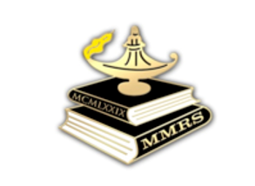 | Maryland Masonic Research Society (MMRS)  Membership Application

The purpose of MMRS is to promote any activity which may further knowledge or understanding of the history, ritual, philosophy, symbolism, or other aspects of Freemasonry and to present and conclusions to the Society for discussion and exchange of ideas.
Membership in the Society is open to anyone interested in supporting the purposes of the Society. Institutional membership is available to libraries, Lodges, and organizations that desire to receive the publications of the Society.
Date:
Applicant’s Name:
Address:
Phone Numbers (circle preferred): Mobile:
Home: Work: Other:
Email Address:
Lodge Affiliation(s) [if any]:

Please describe why you are interested in joining us and any areas of interest that you’d like to learn or hear more about in upcoming MMRS meetings:

Please send your first year’s dues check [$25, payable to MMRS] to:
Maryland Masonic Research Society
P.O. Box 354
Laurel, MD 20725
Website: http://md-mrs.com

